GISBORNE PRESBYTERIAN PARISH

Matawhero Church – Church Lane

St Andrew’s Church and Community Centre:

176 Cobden Street, Gisborne

11 November 2023

Matawhero Special Service of Remembrance

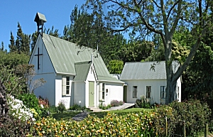

Matawhero Historic Church

Special Service of Remembrance
2pm, Saturday 11 November 2023

Welcome Marie Burgess
Apologies and greetings from people who cannot attend

Hymn: God of nations – Maori and English WOV677
E Ihoa Atua, God of nations, at thy feet,
o nga Iwi Matoura, In the bonds of love we meet;
Ata whakarongona; Hear our voices we entreat,
me aroha noa. God, defend our free land!
Kia hua ko te pai; Guard Pacific’s triple star
Kia tau to atawhai; From the shafts of strife and war,
Manaakitia mai Make her praises heard afar;
Aotearoa. God, defend New Zealand

Call to Worship: led by Jan Ewart

Today we gather in this special place
A place of memories, both painful and joyful
We come to remember our past
And to look to the future with hope
We light this candle and remember that Christ is the light of the world
And we know that the light is stronger than the darkness
That life is stronger than death
That hope is stronger than despair
So let us worship God, in whom we put our trust
Yes, let us worship God – our anchor and our encourager

Opening prayer

Hymn: Praise the one Words CH4 348, tune Austria CH4 738)
Praise the one who breaks the darkness
with a liberating light.
Praise the one who frees the prisoners,
turning blindness into sight.
Praise the one who preached the Gospel,
healing every dread disease,
calming storms and feeding thousands
with the very bread of peace.
Praise the one who blessed the children
with a strong yet gentle word.
Praise the one who drove out demons
with a piercing two-edged sword.
Praise the one who brings cool water
to the desert's burning sand.
From this well comes living water,
quenching thirst in every land.
Praise the one true love incarnate:
Christ who suffered in our place.
Jesus died and rose for many
that we may know God by grace.
Let us sing for joy and gladness,
seeing what our God has done.
Praise the one redeeming glory,
praise the One who makes us one.
[Rusty Edwards]

Litany of Forgiveness Based on Ephesians chapters 2 and 3

Great God of all, when the British troops crossed the Mangatawhiri River to subdue the Waikato iwi,
our nation was divided in two.
Christ, forgive and unite.

When the colonial government confiscated the land of tangata whenua including those whose guardianship it had promised to respect,
our nation was divided in two.
Christ, forgive and unite.

When the police arrested Rua Kenana and government troops invaded the peace-making community of Parihaka,
our nation was divided in two.
Christ, forgive and unite.

When Te Kooti was sent to Wharekauri without trial,
our nation was divided in two.
Christ, forgive and unite.

When Te Kooti took revenge for unjust treatment
and the confiscation of his land,
our nation was divided in two.
Christ, forgive and unite.

When the armed constabulary took their revenge
on Te Kooti’s followers at Ngatapa Pa,
our nation was divided in two.
Christ, forgive and unite.
… Moments of silence …
When we listen now to those who share their story of connection with the Matawhero Tragedy, may our hearts and minds be open, our spirits stirred, and our determination to live in peace, as one undivided nation, be strengthened.
May God flood our hearts and spirits with love and compassion.
Christ unite us in your love. Amen.
Developed from a Litany prepared by Rev Dr Kerry Enright for the 2018
General Assemby of the Presbyterian Church of Aotearoa New Zealand

Sharing our stories:
Dr Stan Pardoe, Kaumatua o Rongowhakaata and Turanganui a Kiwa
Hymn: Tama Ngakau Marie AA128
Tama ngākau mārie  Tama a te Atua  Tēnei tonu mātou  Arohaina mai  Murua rā ngā hara  Wetekina mai  Ēnei here kino  Wakararu nei.  Takahia ki raro  Tau e kino ai  Kei pā kaha tonu  Ko nga mahi hē.  Tama ngākau mārie  Tama a te Atua  Tēnei tonu mātou  Arohaina mai |  | Son of peace  Son of God  here we are always.  Show us compassion.  Wipe away our sins,  and unshackle  these evil ties  that are so troublesome.  Trample down  things evil to you  lest they gather strength,  all evil deeds.  Son of peace  Son of God  here we are always.  Show us compassion.
Marie Burgess, parishioner and great grand-daughter of Robert and Jane Atkins

Choir: Honour the dead vv2.4.5 HS61
Weep for the places ravaged with our blood,
weep for the young bones buried in our mud,
weep for the power of violence and greed,
weep for the deals done in the name of need.

Weep for the waste of all that might have been,
weep for the cost that war has made obscene,
weep for the homes that ache with human pain,
weep that we ever sanction war again.

Honour the dream for which our nation bled,
held now in trust to justify the dead,
honour their vision on this solemn day:
peace known in freedom, peace the only way.
Words: Shirley Murray Music: Colin Gibson

Readings:
Psalm 13 Seton Clare
Luke 24: 13-35 Bev Kirkpatrick

Reflection: The Right Rev Rose Luxford

Prayer for Remembrance Day — from Common Worship: Services and Prayers for the Church of England (2000), “All Saints to Advent.” Copyright 2000 © The Archbishops’ Council. Posted on the Church of England website

Bidding: May God give peace.
Response: God give peace.

….O God of truth and justice,
we hold before you those whose memory we cherish, ….
….As we honour the past,
may we put our faith in your future;
for you are the source of life and hope,
now and for ever.
Amen.
All join together in the Lord’s Prayer
Our Father in heaven, hallowed be your Name,
your kingdom come, your will be done,
on earth as in heaven.
Give us today our daily bread.
Forgive us our sins as we forgive those who sin against us.
Save us from the time of trial and deliver us from evil.
For the kingdom, the power, and the glory
are yours now and forever. Amen

Hymn: ‘Give thanks for life’ Words AA45 Tune Sine Nomine CH4 740
Give thanks for life, the measure of our days,
mortal, we pass through beauty that decays,
yet sing to God our hope, our love, our praise:
Alleluia, Alleluia!

Give thanks for those who made their life a light
caught from the Christ-flame, bursting through the night,
who touched the truth, who burned for what is right:
Alleluia, Alleluia!

And for our own, our living and our dead,
thanks for the love by which our life is fed,
a love not changed by time or death or dread:
Alleluia, Alleluia!

Give thanks for hope that, like the wheat, the grain
lying in darkness, does its life retain
in resurrection to grow green again:
Alleluia, Alleluia!

Benediction:
(3-fold Amen)

Worship Leader: The Right Rev Rose Luxford, Moderator, PCANZ
Speakers:
Dr Stan Pardoe, Kaumatua o Rongowhakaata and Turanganui a Kiwa
Marie Burgess, parishioner and great grand-daughter of Robert and Jane Atkins

Readers in order of reading: Jan Ewart
Seton Clare
Bev Kirkpatrick

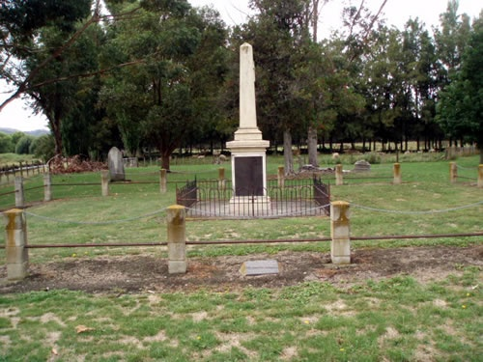
Makaraka memorial

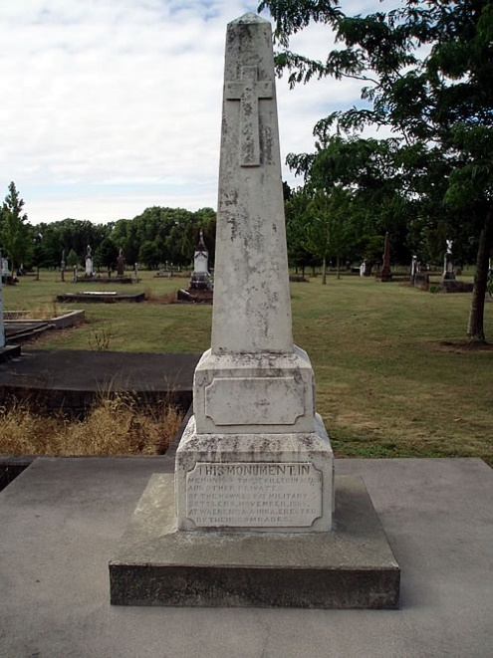
Waerenga-a-hika memorial

