GISBORNE PRESBYTERIAN PARISH
WELCOME TO MATAWHERO CHURCH

Matawhero Church – Church Lane

St Andrew’s Church and Community Centre:

176 Cobden Street, Gisborne

5 June, 2022

Pentecost Sunday

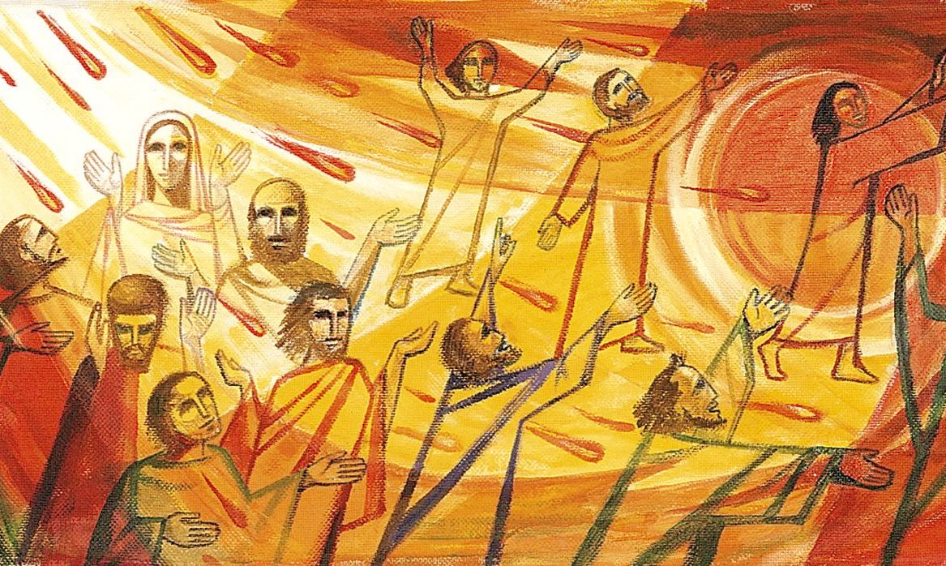

Ministers: All the people in Christ Minister: Rev Jin Sook Kim
Director of Music: Catherine Macdonald

We gather together as the people of God
Kia Ora, Talofa, Bula, Shalom and Annyeong-haseyo

Greetings with news and notices

Call to Worship
God, at Pentecost, You spoke through flame and fire
As we gather, through the power of Your Spirit,
may we follow Your call.
God, at Pentecost, Your Advocate spoke truth in our world
As we gather, through the power of Your Spirit,
may we hear and obey.
God, at Pentecost, You celebrated the gifts of diversity in cultures
As we gather, through the power of your Spirit,
may You hear our heart languages of prayer and praise.
God, at Pentecost, Your Helper offered peace to every troubled heart
As we gather, through the power of Your Spirit,
may You calm every anxious heart.

We sing - Come Holy Spirit, Come! CH3 104, vv1-5

Prayers

Readings
First reading: Genesis 11:1-9
Second reading: Acts 2:1-21
Gospel reading: John 14:25-27

Sermon – The sounds of the Holy Spirit

Prayers of Intercession

Offering

We sing – Take our bread, WB 74, vv1-2

Communion – WB – B (page 7)

We sing – This is the day, WB79, vv1-3

Sending
The Grace

The Grace of our Lord Jesus Christ, the love of God and the fellowship of the Holy Spirit be with us all, now and forever.

Sing: AMENx3 CH4#819

