GISBORNE PRESBYTERIAN PARISH
WELCOME TO ST ANDREW’S GISBORNE

Matawhero Church – Church Lane

St Andrew’s Church and Community Centre:

176 Cobden Street, Gisborne

5 June, 2022

Pentecost Sunday

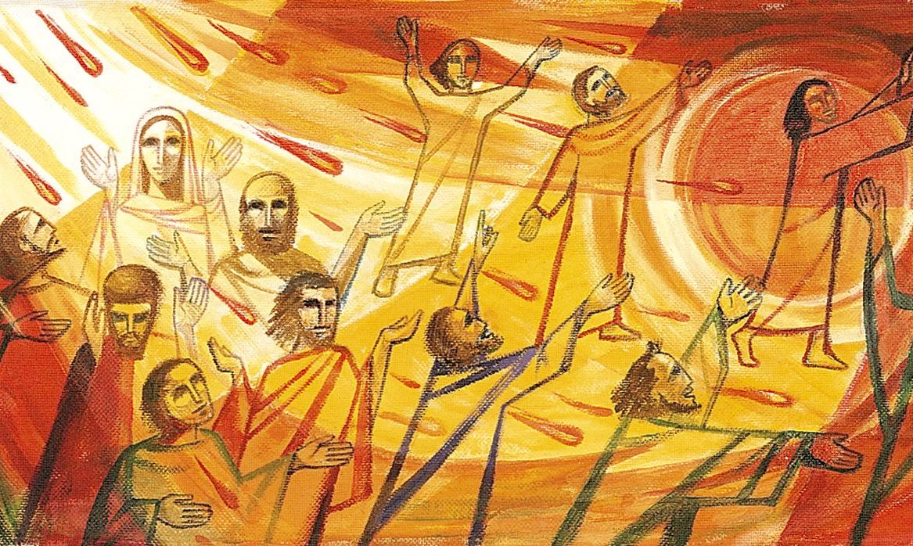

Ministers: All the people in Christ Minister: Rev Jin Sook Kim
Director of Music: Catherine Macdonald

We gather together as the people of God
Kia Ora, Talofa, Bula, Shalom and Annyeong-haseyo

Greetings with news and notices

Introit – Be still, Words & Music © 1986, Thankyou Music, CH4189, vv1-2
- Be still for the presence of the Lord, the Holy One, is here;
come bow before him now with reverence and fear:
in him no sin is found – we stand on holy ground.
Be still for the presence of the Lord, the Holy One, is here.

- Be still for the glory of the Lord is shining all around;
he burns with holy fire, with splendour he is crowned:
how awesome is the sight – our radiant king of light!
Be still, for the glory of the Lord is shining all around.

Call to Worship
God, at Pentecost, You spoke through flame and fire
As we gather, through the power of Your Spirit,
may we follow Your call.
God, at Pentecost, Your Advocate spoke truth in our world
As we gather, through the power of Your Spirit,
may we hear and obey.
God, at Pentecost, You celebrated the gifts of diversity in cultures
As we gather, through the power of your Spirit,
may You hear our heart languages of prayer and praise.
God, at Pentecost, Your Helper offered peace to every troubled heart
As we gather, through the power of Your Spirit,
may You calm every anxious heart.

We sing - Come Holy Spirit, Come! Words © 1992, Kevin Mayhew Ltd., CH4 594, vv1-5

Come, Holy Spirit, come!
Inflame our souls with love,
transforming every heart and home
with wisdom from abo e.
Let none of us despise
the humble path Christ trod,
But choose, to shame the worldly wise,
the foolishness of God.

All-knowing Spirit, prove
The poverty of pride,
by knowledge of the Father’s love
in Jesus crucified.
And grant us faith to know
the glory of that sign,
and in our very lives to show
the marks of love divine.

Come with the gift to heal
the wounds of guilt and fear,
And to oppression’s face reveal
the kingdom drawing near.
Where chaos longs to reign,
descend, O holy Dove,
And free us all to work again
the miracles of love.

Spirit of truth, arise;
inspire the prophet’s voice:
expose to scorn the tyrant’s lies,
and bid the poor rejoice.
O Spirit, clear our sight,
all prejudice remove,
and help us to discern the right,
and covet only love.

Give us the tongues to speak
The word of love and grace
To rich and poor, to strong and weak,
In every time and place.
Enable us to hear
The words that others bring,
Interpreting with open ear
The special song they sing.

Prayers

Story Time – Tower of Babel (play for 3 min)
https://www.youtube.com/watch?v=CW-NXNzdZhM

Question: According to the bible, long time ago, there used to be only one language. How do we have many languages now?

We sing – Lord, you sometimes speak in wonders, Words:
© Christopher Idle, CH4 606, vv1-5
Lord, you sometimes speak in wonders,
unmistakable and clear,
mighty signs that show your presence,
overcoming doubt and fear.

Lord, you sometimes speak in whispers,
still and small and scarcely heard;
only those who want to listen
catch the all-important word.

Lord, you sometimes speak in silence,
through our loud and noisy day;
we can know and trust you better
when we quietly wait and pray.

Lord, you sometimes speak in Scripture,
words that summon from the page,
shown and taught us by your Spirit
with fresh light for every age.

Lord, you always speak in Jesus,
always new yet still the same:
teach us now more of our Saviour,
make our lives display his Name.

Readings
First reading: Genesis 11:1-9
Second reading: Acts 2:1-21

Gospel reading: John 14:25-27

Sermon – The sounds of the Holy Spirit

Anthem – Great and deep the Spirit’s purpose, Music © Colin Gibson, Words © Marnie Barrell, AA 1-4

Great and deep the Spirit’s purpose,
hidden now in mystery,
nature bursts with joyful promise,
ripe with what is yet to be.
In a wealth of rich invention,
still the work of art unfolds:
barely have we seen, and faintly,
what God’s great salvation holds.

Great and deep the Spirit’s purpose,
making Jesus seen and heard.
Every age of God’s creation
grasps new meaning from the Word.
Show us, Holy Spirit, show us
your new work begun today:
eyes and ears and hearts are open,
teach us what to do and say.

Great and deep the Spirit’s purpose:
all God’s children brought to birth,
freed from hunger, fear and evil
every corner of the earth,
and a million million voices
speak with joy the Saviour’s name;
every face reflects his image,
never any two the same.

Great and deep the Spirit’s purpose,
nothing shall be left to chance.
All that lives will be united
in the everlasting dance.
All fulfilled and all perfected,
each uniquely loved and known,
Christ in glory unimagined
once for all receives his own.

Prayers of Intercession

Offering

We sing - We sing a love that sets all people free, Words: ©1993 Stainer Bell Ltd. CH4 622, vv1-5
We sing a love that sets all people free
that blows like wind, that burns like scorching flame,
enfolds the earth, springs up like water clear:
come, living love, live in our hearts today.

We sing a love that seeks another’s good,
that longs to serve and not to count the cost,
a love that, yielding, finds itself made new:
come, caring love, live in our hearts today.

We sing a love, unflinching, unafraid
to be itself, despite another’s wrath,
a love that stands alone and undismayed:
come, strengthening love, live in our hearts today.

We sing a love, that, wandering, will not rest
until it finds its way, its home, its source,
through joy and sadness pressing on refreshed:
come, pilgrim love, live in our hearts today.

We sing the Holy Spirit, full of love,
who seeks out shades of ancient bitterness,
brings to our wounds the healing grace of Christ:
come, radiant love, live in our hearts today.

Words: ©1993 Stainer Bell Ltd. CH4 622, vv1-5

Sending
The Grace

The Grace of our Lord Jesus Christ, the love of God and the fellowship of the Holy Spirit be with us all, now and forever.

Sing: AMENx3 CH4#819

