GISBORNE PRESBYTERIAN PARISH
WELCOME TO ST ANDREW’S GISBORNE

Matawhero Church – Church Lane

St Andrew’s Church and Community Centre:

176 Cobden Street, Gisborne

26 June 2022 Pentecost 3

Celebration Pot Luck service with Matariki

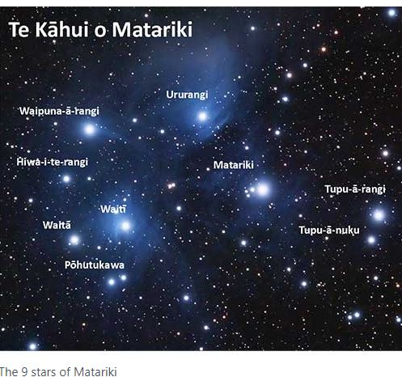

Ministers: All the people in Christ Minister: Rev Jin Sook Kim
Director of Music: Catherine Macdonald

We gather together as the people of God
Kia Ora, Talofa, Bula, Shalom and Annyeong-haseyo

Greetings with news and notices

Introit – Tama ngakau marie, WB 105, vv 1-2 & 5

Call to Worship
Great is our God and greatly to be praised!
The whole earth reflects God’s power and might.
When we recall the wonders of God’s creation….
We rejoice at the awesome complexity of it all.
Lord, you have brought us up from fear to hope.
Let us worship and praise God for all God’s faithfulness. AMEN.

We sing – Longing for light, we wait in darkness, Words and Music: © 1993, Barnadette Farrell, CH4 543, vv1-5

Longing for light, we wait in darkness.
Longing for truth, we turn to you.
Make us your own, your holy people,
Light for the world to see.

Refrain
Christ, be our light!
Shine in our hearts.
Shine through the darkness.
Christ, be our light!
Shine in your Church gathered today.

Longing for peace, our world is troubled.
Longing for hope, many despair.
Your word alone has power to save us.
Make us your living voice.

Longing for food, many are hungry.
Longing for water, many still thirst.
Make us your bread, broken for others,
Shared until all are fed.

Longing for shelter, many are homeless.
Longing for warmth, many are cold.
Make us your building, sheltering others,
Walls made of living stone.

Many the gifts, many the people,
Many the hearts that yearn to belong.
Let us be servants to one another,
Making your kingdom come.

Prayers

Celebration Time
Celebrations today
May God bless you we pray
Live for Jesus dear people
May he guide you each day.

Story time

Matariki activities

We sing – Amazing Grace WB 3, vv1-4

Reading
Reading – Galatians 5:1, 13-25

Reflection

Offering

We sing – I the Lord of sea and sky, Words and Music © 1981, OCP Publications, CH4 251, vv1-3
I, the Lord of the sea and sky,
I have heard my people cry.
All who dwell in dark and sin
My hand will save.
I, who made the stars of night,
I will make their darkness bright.
Who will bear my light to them?
Whom shall I send?

Here I am, Lord.
Is it I, Lord?
I have heard you calling in the night.
I will go, Lord,
if you lead me.
I will hold your people in my heart.

I, the Lord of snow and rain,
I have borne my people’s pain.
I have wept for love of them.
They turn away.
I will break their hearts of stone,
Give them hearts for love alone.
I will speak my Word to them.
Whom shall I send?

I, the Lord of wind and flame,
I will tend the poor and lame.
I will set a feast for them.
My hand will save.
Finest bread I will provide
till their hearts be satisfied.
I will give my life to them.
Whom shall I send?

Sending
Lights of the world, Light of Matariki stars
Light of Marama – the moon, Light of Ra – the sun
Light of worlds and galaxies, All these lights in Christ
Reflect off us, Shine in us
That we may be light-bearers, Love-makers
Care-givers, Let us be light. Let us shine!

The Grace
Kia tau ki a tātou katoa
Te atawhai o tō tātou Ariki, a Ihu Karaiti Me te aroha o te Atua
Me te whiwhingatahitanga, Ki te wairua tapu
Ake, ake, ake
Amine
The Grace of our Lord Jesus Christ, the love of God and the fellowship of the Holy Spirit be with us all, now and forever.

Sing: AMENx3 CH4#819

Celtic Blessing for a meal

