GISBORNE PRESBYTERIAN PARISH
WELCOME TO ST ANDREW’S GISBORNE

Matawhero Church – Church Lane

St Andrew’s Church and Community Centre:

176 Cobden Street, Gisborne

8 January 2023 Epiphany 1

COMMUNION SUNDAY

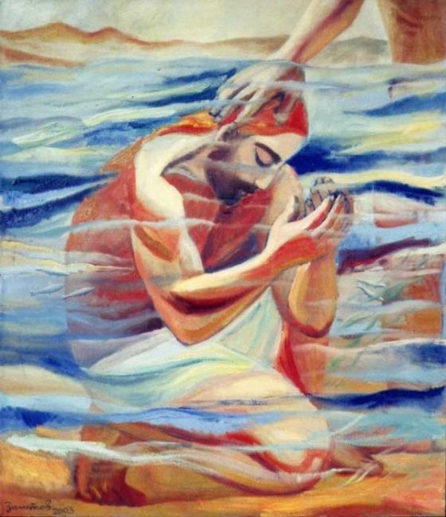

Minister: Rev Jin Sook Kim
Reader: Bob Boss Organist: David Russell
Director of Music: Catherine Macdonald

We gather together as the people of God
Kia Ora, Talofa, Bula, Shalom, Dobry den and Annyeong-haseyo

Greetings with news and notices

Introit – Spirit of God, unseen as the wind, Words © Scripture Union, Arrangement © Church of Scotland Panel on Worship, CH4 600, 1-2

Refrain Spirit of God, unseen as the wind,
Gentle as is the dove,
teach us the truth and help us believe,
show us the Saviour’s love.

You spoke to us long, long ago,
gave us the written word;
we read it still, needing its truth,
through it God’s voice is heard.

Without your help we fail our Lord,
we cannot live his way;
we need your power, we need your strength,
following Christ each day.

Call to Worship

In the very beginning, God separated the darkness and the light.
God called the Light "Day" and the Darkness, God called "Night".
Once we dwelled in darkness,
but now we live in the true Light, Jesus Christ.
God has blessed us and adopted us as God’s own beloved children,
through the sacrament of Baptism.
The water of baptism brings to us healing and reconciliation.
This day is the day of the remembrance of Jesus’ Baptism.
We celebrate the joyous connection to the Almighty God through
our adoption by God.

We sing - God, whose almighty word, Harmonization © Oxford University Press, CH4 112, 1-4

God, whose almighty word
chaos and darkness heard,
and took their flight; hear us,
we humbly pray,
and, where the gospel-day
sheds not its glorious ray,
let there be light.

Saviour, who came to bring,
on your redeeming wing,
healing and sight,
health to the sick in mind,
sight to the inly blind,
now to all humankind
let there be light.

Spirit of truth and love,
life-giving, holy dove,
Speed forth your flight;
move o’er the waters’ face,
bearing the lamp of grace,
and in earth’s darkest place
let there be light.
Blessed and holy Three,
glorious Trinity,
Wisdom, Love, Might,
boundless as ocean‘s tide
rolling in fullest pride,
through the world far and wide
let there be light.

Prayers
We sing – Christ is our light, TUNE: EVENTIDE (CH4 393),CH4 336, 1-3

Christ is our light! the bright and morning star
covering with radiance all from near and far.
Christ be our light, shine on, shine on we pray
Into our hearts, into our world today.

Christ is our love! baptized that we may know
The love of God among us, swooping low.
Christ be our love, bring us to turn our face
And see in you the light of heaven’s embrace.

Christ is our joy! transforming wedding guest!
Through water turned to wine the feast was blessed.
Christ be our joy; your glory let us see,
as your disciples did in Galilee.

Readings
First reading: Acts 10:34-43
Gospel Reading – Matthew 3:13-17

Sermon – Being baptized in Christ

A CONGREGATIONNAL REAFFIRMATION OF BAPTISM
Brothers and sisters in Christ … Today we come to reaffirm our baptism, declaring our allegiance to the risen Christ and seeking to be obedient to his will.

REAFFIRMATION OF BAPTISM

Do you repent of your sins?
I repent of my sins.

Do you turn to Jesus Christ
who has defeated the power of sin and death
and brought us new life?
I turn to Christ.

Do you commit yourself to God,
Trusting in Jesus Christ as Saviour
And in the Holy Spirit as God’s power and presence along the way?
I commit myself to God.

THE APOSTLES’ CREED

And now I ask you to confess the faith
…to live and grow.

Do you believe in God?
I believe in God, the Father almighty,
Creator of heaven and earth.
Do you believe in Jesus Christ?
I believe in Jesus Christ, God’s only Son, our Lord,
Who was conceived by the Holy Spirit,
Born of the Virgin Mary,
Suffered under Pontius Pilate,
Was crucified, died, and was buried;
He descended to the dead.
On the third day he rose again;
He ascended into heaven,
He is seated at the right hand of the Father,
And he will come to judge the living and the dead.

Do you believe in the Holy Spirit?
I believe in the Holy Spirit,
The holy catholic Church,
The forgiveness of sins,
The resurrection of the body,
And the life everlasting. Amen.

This is the faith of God’s baptized people.
We are not ashamed to confess it
In Christ our Lord.

COMMITMENT TO MISSION

I ask you now …in the world.

Will you continue in the community of faith,
The apostles’ teaching,
The breaking of bread and the prayers?
With God’s help, we will.

Will you proclaim by word and example the good news of God in Christ:
With God’s help, we will.

Will you seek Christ in all people,
And love your neighbour as yourself?
With God’s help, we will.

Will you strive for justice and peace,
And respect the dignity of every human being?
With God’s help, we will.

May almighty God, …
Through Jesus Christ our Lord.
Amen.

RECOLLECTION OF BAPTISM
(The People remain standing. Water is poured into the font.)

Come, Lord Jesus, …you are baptized, and be thankful.

THE SIGN OF THE CROSS
(The people remain in their places.)

Today we remember that, from the time of our baptism,
The sign of the cross has been upon us.
I invite you now to join me
In tracing the sign of the cross upon your forehead,
Saying: I belong to Christ. Amen.
I belong to Christ. Amen.

You may trace the sign of the cross
On those around you,
Saying: You belong to Christ. Amen.
You belong to Christ. Amen.

Pastoral Prayer

Lord, in your mercy,
Hear our prayer.

We sing – I bind unto myself today, TUNE: THE BANKS O’DOON (CH4 718), CH4 639 (i) 1-2 & 4-6
I bind unto myself today
the strong Name of the Trinity;
by invocation of the same,
the Three in One, and One in Three.

I bind this day to me forever,
by power of faith, Christ’s Incarnation:
his baptism in the Jordan river;
his death on cross for my salvation;
his bursting from the spiced tomb;
his riding up the heavenly way;
his coming at the day of doom:
I bind unto myself today.

I bind unto myself today
the power of God to hold and lead,
his eye to watch, his might to stay,
his ear to hearken to my need,
the wisdom of my God to teach,
his hand to guide, his shield to ward,
the word of God to give me speech,
his heavenly host to be my guard
Christ be with me, Christ within me,
Christ behind me, Christ before me,
Christ beside me, Christ to win me,
Christ to comfort and restore me,
Christ beneath me, Christ in danger,
Christ in hearts of all that love me,
Christ in mouth of friend and stranger.

I bind unto myself the name,
the strong Name of the Trinity,
by invocation of the same,
the Three in One, and One in Three,
of whom all nature hath creation,
Eternal Father, Spirit, Word.
Praise to the Lord of my salvation:
salvation is of Christ the Lord. Amen.

Prayers of Intercession

Offering
We sing - For the bread and wine and blessing, Music © Guy Jansen, Words © Shirley Murray, AA 39, 1-4

For the bread and wine and blessing,
for the friends around this table,
for the peace and for the healing,
we celebrate you, Jesus Christ.

For the faithful of all ages,
for the dead and for the living,
for the hope that we remember,
we celebrate you, Jesus Christ.

When your love breaks through our darkness,
when the broken come to wholeness –
for each sign of resurrection,
we celebrate you, Jesus Christ.

Alleluia, alleluia,
alleluia, alleluia,
alleluia, alleluia,
we celebrate you, Jesus Christ.

[COMMUNION]
Liturgy C

We sing – Spirit of God, descend upon my heart, TUNE: WOODLANDS (CH4 286), CH4 495, 1-5
Spirit Of God, descend Upon my heart;
wean it from Earth; through all Its pulses move;
stoop to my weakness, mighty as thou art;
and make me love thee as I ought to love.
I ask no dream, no prophet - ecstasies,
no sudden rending of the veil of clay,
no angel -visitant, no opening skies;
but take the dimness of my soul away.
Hast thou not bid me love thee, God And King -
all, all thine own, soul, heart and strength, and mind.
I see thy cross - there teach my heart to cling:
oh, let me seek thee, and oh, let me find!
Teach me to feel that thou art always nigh;
teach me the struggles of the soul to bear.
to check the rising doubt, the rebel sigh,
teach me the patience of unanswered prayer.

Teach me to love thee as thine angels love,
one holy passion filling all my frame;
the baptism of the heaven- descended Dove,
my heart an altar, and thy love the flame.
Sending
The Grace
Kia tau ki a tātou katoa
Te atawhai o tō tātou Ariki, a Ihu Karaiti Me te aroha o te Atua
Me te whiwhingatahitanga, Ki te wairua tapu
Ake, ake, ake
Amine
The Grace of our Lord Jesus Christ, the love of God and the fellowship of the Holy Spirit be with us all, now and forever.
Sing: AMENx3 CH4#819

