#### **GISBORNE PRESBYTERIAN PARISH**

#### *Matawhero Church – Church Lane*

#### *St Andrew’s Church and Community Centre:*

#### *176 Cobden Street, Gisborne*

#### [*www.standrewsgis.org.nz*](http://www.standrewsgis.org.nz)

***6 October 2024 World Communion Sunday Pentecost 20***

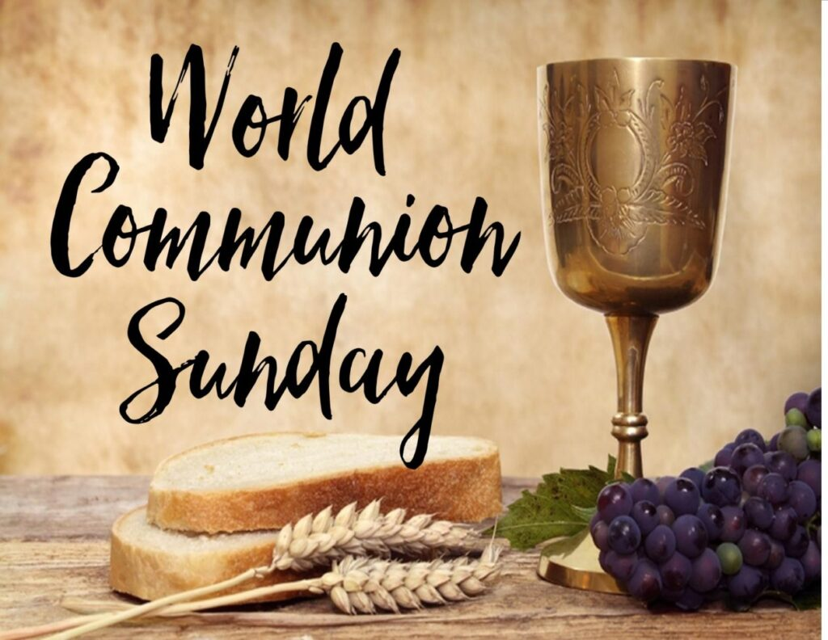

***We welcome all visitors to our service this morning.***

***Please sign the Visitors’ Book and make yourself known to the Hosts who stand at the back of the church. A toilet is located in the foyer.***

***In our worship we use inclusive language as much as possible. Sometimes, especially in the hymns, this is not possible. Feel free to insert the language with which you are most comfortable. BOLDED WORDS are for congregational response.***

***Where there is an asterisk * please stand.***

**News and information**

**Silence**

**Call to Worship** (Lamentations 3, Psalm 137)

One: Sing to the Lord, whose mercy is from everlasting to everlasting!

Many: **But how can we sing the Lord’s song when so many are without?**

One: Sing to the Lord, whose faithfulness renews us every morning!

Many: **But how can we sing the Lord’s song when so many are gone?**

One: Sing to the Lord, who has not forgotten the melodies of salvation!

Many: **Let us remember the joy of the Lord, and sing a new song together!**

**Opening Prayer**

Almighty God,

even as the drums of warfare beat on through the night,

even as the cries of injustice linger in the morning,

even as the hustle of busyness rumbles through the day,

quiet our hearts. Still our thoughts. Join us in our worship.

Remember us in your mercy as we try to remember you,

through the proclamation of your good news, in story and in song,

and through the hospitality of your gracious table.

Welcome us again, one Lord,

Creator, Son, and Holy Spirit. Amen.

**Opening Hymn** Now to your table spread WB 58

**Call to Confession**

Great indeed is the faithfulness of God, and yet our hearts are not so reliable. We wander. We argue. We forget. We divide ourselves with anger and bitterness and falsehood. Let’s try to come back together again, and let’s start with the truth. Let’s confess our sins, to God, and also, to each other.

**Prayer of Confession**

Almighty God, mother of mercy, father of grace: You have called us to one table, but we have pursued our own course. You have promised us the abundance of all creation, but in our greed, and in our envy, the world goes without. You have promised us the bread of life itself, but in our pride, and in our arrogance, the world goes hungry. You have promised us the waters of peace and justice, but in our violence, and in our discord, the world goes thirsty. And now we are famished, too, Lord. Have mercy on us. Forgive us, again. Transform us, at this table, and for this table, and send us from this table as servants of your righteousness, by the power of your Son, our Lord. **Amen**.

**Assurance of Pardon** (at the font)

Even when our cups run dry, God’s grace overflows.

Even when our plates are empty, God’s generosity overflows.

And even when our hearts feel barren, God’s love overflows.

Friends, you have been called and claimed by the God of all things,

and by the abundance of God’s grace,

and by the power of God’s love,

your sins have been forgiven.

Go in peace.

**Amen**.

**Family Time**

**God of us all,**

**we remember our brothers and sisters around the world today.**

**Help us to treat all people as your children.**

**Amen.** -Contributed by Holly Purcell Albrecht

**Sharing the Peace of Christ**

**Prayer for Illumination** (Luke 17:5–10)

Almighty God,

give us ears to hear your story in these words of Scripture;

give us eyes to see your story in the faces of those that surround us;

and give us faith enough, that by your grace,

we might serve you until the end of our days.

**Amen.**

**Scripture** 2 Timothy 1:1–14 Luke 17:5–10 NIV

**Hymn** Feed us now WB14

Affirmation of Faith (adapted from the Belhar Confession)

We believe in one holy, universal Christian church,

the unity of the communion of saints of the entire human family.

And we believe that that this unity of the people of God

must be manifest and active,

in that we love one another;

that we give ourselves willingly and joyfully to one another,

that we are share one baptism together,

that we eat of one bread and drink of one cup together,

that we confess one name, one Lord, for one cause, with one hope,

which is the height and the breadth and the depth

and the love of Christ, forever and ever. **Amen**.

**Call for Offering**

We approach the table today but we don’t approach it alone. We approach it on this World Communion Sunday with Christians around the world, in congregations large and small, speaking every language and one language. And so part of our approach this morning is to remember in our offering our connection to the work of the church in every corner of God’s creation. We do this using the PC(USA) Peace and Global Witness Offering, which goes to support advocacy, education, and educational outreach with communities of faith all across the globe. Truly, God has blessed us with the rich, varied, and abundant gifts of creation. From God’s abundance, let us also give abundantly.

**Prayer of Thanksgiving**

Gracious God, you create more than we could ever hope to return.

You share more than we could ever hope to deserve.

And yet, we pray, accept these humble gifts.

May they honour and glorify you in all creation,

and may they empower us for the work of witness and service,

for the sake of justice, and for the sake of peace,

now and forever. **Amen.**

**Eucharist**

**Invitation**

This table is for all of us,

near and far, high and low, east and west and north and south.

This table is for all of us, but it is not our table.

It’s not a Presbyterian table. It’s not an American table.

It’s God’s table, for all of us, and it’s a table of grace.

So come and take your place at the table.

You are welcome, you are invited, you are called:

come, let us share this meal together.

**Great Prayer of Thanksgiving**

One: The Lord be with you.

Many: **And also with you.**

One: Lift up your hearts.

Many: **We lift them to the Lord.**

One: Let us give thanks to the Lord our God.

Many: **It is right to give our thanks and praise.**

One:

It is truly right and our greatest joy to give you thanks and praise,

O Lord our God, creator and ruler of the universe.

Even when we were dust, when our story begins in dust,

you were there, your word was there,

your breath into the lifeless void.

And upon your word all creation sprang into life.

When we were in the wilderness, terrified, timid,

you were there, your word was there,

with manna just enough for today,

with water even from the driest rock,

with the abundant grace upon which our story always rests.

And when we fell short, slaves to power and greed,

you were there, your word was there,

on the lips of prophets, and in the hearts of servants,

in stories of revolution and revelation and liberation,

calling us even now to acts of courage and witness and peace.

Therefore we praise you, joining our voices with choirs of angels,

with prophets, apostles, and martyrs,

and with all the faithful of every time and place,

who forever sing to the glory of your name:

Many:

**Holy, holy, holy Lord, God of power and might,**

**heaven and earth are full of your glory.**

**Hosanna in the highest.**

**Blessed is he who comes in the name of the Lord.**

**Hosanna in the highest.**

One:

Blessed is he who comes in the name of the Lord.

Indeed blessed are you, O Christ, our Lord,

for risking yourself among us, vulnerable and rejected;

for teaching among us, teaching the radical hope of God;

teaching grace to a world bent on vengeance,

teaching love to a world bent on destruction,

teaching peace to a world bent on tearing itself apart.

You were there, your word was there, even to the point of death itself.

Even faced with terror and hatred and the brokenness of the world,

you rose again, to new life, to new creation, to resurrection,

that we might know something other than the dust,

that we might expect something other than the end,

that we might work for something other than ourselves.

And so you speak to us us again,

with these abundant gifts of bread and wine,

with which we joyfully celebrate your dying and rising,

as we await the table of the Kingdom yet to come,

and as we dedicate ourselves again to you,

thankful, and transformed, as living and holy sacrifices,

that our lives may proclaim the one crucified and risen.

Great is the mystery of faith:

Many:

**Christ has died,**

**Christ is risen,**

**Christ will come again.**

One:

Gracious God, pour out your Holy Spirit upon us,

and upon these your gifts of bread and wine,

that the bread we break together, and the cup we share together,

may retell our common stories together

and reshape our common bonds together,

and remember our common grace together,

in the communion of the body and blood of your Son Jesus Christ,

the one in whose life and death you have torn down our divisions.

And so may we be one with all who share this feast,

on this day, of all days, with all your children at every corner of your table.

May we share this abundant cup with all those who thirst for your justice.

May we share this abundant bread with all those who hunger for your righteousness,

May we be united with every corner of your story,

united in hope, united in vision, united in purpose,

united in ministry in every place.

As this bread is Christ’s body for us,

send us from this table to be the body of Christ in all the world.

Send us with a spirit of courage, a spirit of power and love,

that we may be witnesses in all creation

to the unending story of your word breathing life into the dust.

Keep us faithful, and fruitful, and hopeful, and peaceful,

until we come at last to the one table of your Kingdom,

to feast with all your saints in the joy of your eternal realm,

with you and with your Word, through Christ and in Christ,

the one who came for us, died for us, and rose for us,

the one who prays even for us, the one who first taught us to pray,

saying: **Our Father…** (WB pink section p1)

**Breaking the Bread** *The words of institution are spoken here.*

**Hymn** during Communion Take our Bread WB74

**Prayer after Communion**

Gracious God, we offer our thanks,

for the whole communion of saint’s witness to this feast,

and for the ministry of churches around the world who gather with us today.

By this broken bread may we each be restored for the work yet to come.

By this shared cup may we each be claimed for the proclamation of your Kingdom.

At this shared table may we be united as children of your promise,

children of your word, dying and made new again,

sent boldly together into the world as servants of your peace.

**Amen**.

**Closing Hymn** Let us talents and tongues WB37

**Charge and Benediction** (from the table)

You were called to this table.

You were fed at this table.

You were united at this table.

Now, you are sent from this table

into all the world.

Go therefore into the world, with courage.

Set a place for all who hunger.

Fill the cup of all who thirst.

And as you go,

May the Spirit of power and love attend you,

may the grace of our Lord Jesus Christ uphold you,

and may the great faithfulness of our God sustain you,

now and forever.

**Amen.**

Written by Matt Gaventa, the Pastor of Amherst Presbyterian Church in Amherst, Virginia, and the chaplain at Sweet Briar College. Matt is the 2012 recipient of the David H.C. Read Preacher/Scholar Award from Madison Avenue Presbyterian Church, and his writing has appeared in *The Christian Century, WorkingPreacher,* and on the Day 1 Radio Broadcast. He lives in Lovingston, Virginia, with his wife and son, Sarah and Charlie.

**Ministers*:*** *All the people in Christ* **Leader and Celebrant*:*** *Pat Flockhart*

**Reader:** *Lynnor Cooke*

*Please join us for a time of fellowship and friendship over a cup of tea or coffee after the service*

**Note:** The offering is now received at the door as we enter. If you miss noticing this, you may place a retiring offering in the offering boxes at the door as you leave.

**Mindful Prayer topics:** **Oct 6th & 13th 2024** Global Tensions and those holding the reins of power. GPP and the way forward. Parish Councillors, scenarios and thoughts arising from Rev Peter McKenzie's visit. Patients and recovery. Rest homes – staff, volunteers clients and families.

.Mindful Prayer contact Margaret Graham ph. 021 026 03990 or email [m.n.e.gra@xtra.co.nz](mailto:m.n.e.gra@xtra.co.nz)

#### **DIARY**

**SUNDAY 6** **PENTECOST 20 World Communion Sunday**

**Mid Spring School Holidays**

**10.00am St. Andrew’s Communion in Side**

**Chapel** Pat Flockhart

**Matawhero– no Service**

Monday 7 9.00am Walking Group

Tuesday 8 10.00am Open Door All welcome

1.30pm Kiri Te Kanawa R/V

Wednesday 9 3.00pm TeWiremu R/H

Friday 11 1.00pm Choir rehearsal

Saturday 12 8-11.30am Cat Boot sale

**SUNDAY 13** **PENTECOST 21 Spring School Holidays end**

**10.00am St. Andrew’s Service in Side Chapel**

**Rev Dr Clive Yates**

**Matawhero– no Service**

Christian Blind Mission accepts used stamps. Send directly to them or Val Hall. (Leprosy Mission no longer accepts stamps)

**Please remember** donations for the Love basket when shopping. All offerings gratefully received.

Val Hall and Pat Flockhart are offering Home Communion, and they need an Elder to be present. Any Elders willing to assist, please phone or email Val Hall.

For all Pastoral care needs please contact one of the committee members:

Jenny Lawton  868 4268; Ruth McLennan 021 02704867; Jan Gordon 0211836008 Annette Ormiston 0275535028 Barbara Larsen 863-9009

|  |  |  |  |  |
| --- | --- | --- | --- | --- |
| Sunday | Reader | Door & Team | Morning Tea | Sound Visual |
| 6 October  Pentecost 20  Communion in St A’s Side chapel  Pat Flockhart AGM | **Matawhero**  No service  **St Andrew’s**  Lynnor Cooke | **Seton Clare**  Cathy Porter  Sarah McConnochie | Ruth McLennan | S&V: N/A  C:N/A |
| 13 October  Pentecost 21  St A’s Side chapel Rev Dr  Clive Yates | **Matawhero**  No service  **St Andrew’s**  Colleen Skuse | **Chrissie Parker**  Pat Flockhart ,Jenny Lawton | Paulina Melief | S&V: N/A  C: N/A |

***Gisborne Presbyterian Parish***

***St Andrew’s Church and Matawhero Historic Church:***

***Office: 06 868 5513******Hours 10-12 Tuesday – Thursday***

***176 Cobden Street 4010 Bank A/c number 03-0638-0462917-000***

[standrewsgisb@xtra.co.nz](mailto:standrewsgisb@xtra.co.nz)[www.standrewsgis.org.nz](http://www.standrewsgis.org.nz)